**JVM**

**Java Virtual Machine** is responsible for to load the .class file and run the .class file.

It is a part of JRE.

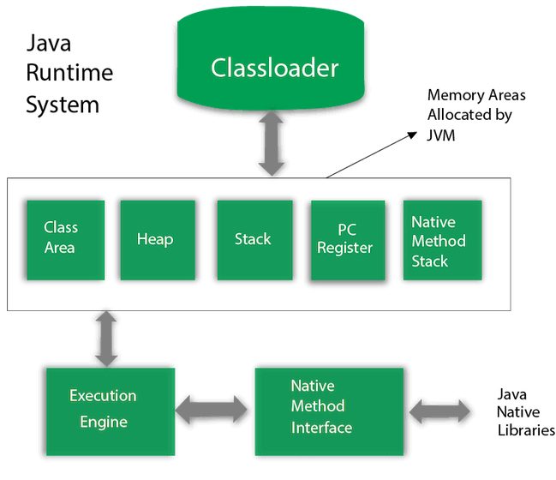

**Garbage Collection**

**What is Garbage Collection in Java?**

It is an automatic process in JVM it will looking in heap memory and identify those object which is not in use and allow to collect as Garbage and delete it.

Main Advantage is it handle the burden of manual memory allocation and deallocation.

**Where Object are is Created in Memory?**

Whenever object is created it will always store in Heap Memory and stack memory hold its reference?

**Who is Responsible to handle Garbage Collection?**

JVM is for responsible.

How can we request the garbage collection?

Call the **System.gc()** method.

**Different ways to make an Object eligible for GC.**

* Set Object is Null.
* Make reference variable to refer another object.
* Create Island of Isolation.

**What is the purpose of Overriding finalize() method?**

It is method by call the Garbage Collectors just before collecting any objects which is eligible to GC.

**How many time does the Garbage Collector calls the finalize() method?**

Only Once.

**What is Responsibility of Garbage Collectors?**

To free the memory.

**Is Garbage Collector a foreground thread or background thread?**

Garbage collector is Background / Demon thread.

**What is Demon Thread?**

It runs behind the application.

It run by JVM.

This thread stop when all non-demon / foreground thread will stop.